Module 4 – DynamoDB

Assignment 2: How to create Dynamo DB table and Write Data in table

Below are the steps to create Amazon DynamoDB table.

Step 1: Search DynamoDB in AWS Console search box:

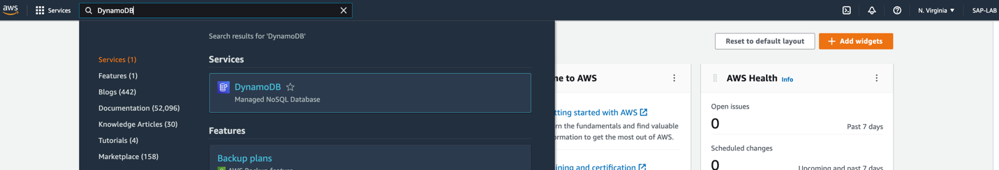

Step 2: Click on ‘**Create table’**-

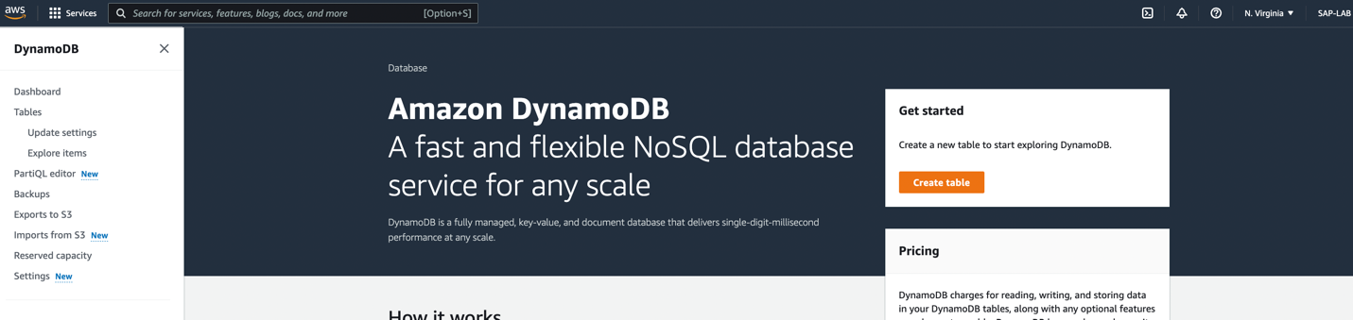

Step 3: Configure the details for table –

1. Table name – put table name
2. Partition key – put the part of primary key, it works like hash value to retrieve the data
3. Sort key – It is second part of Primary key, and works to sort data
4. Table setting – keep as it is.
5. Click on ‘**Create Table’**

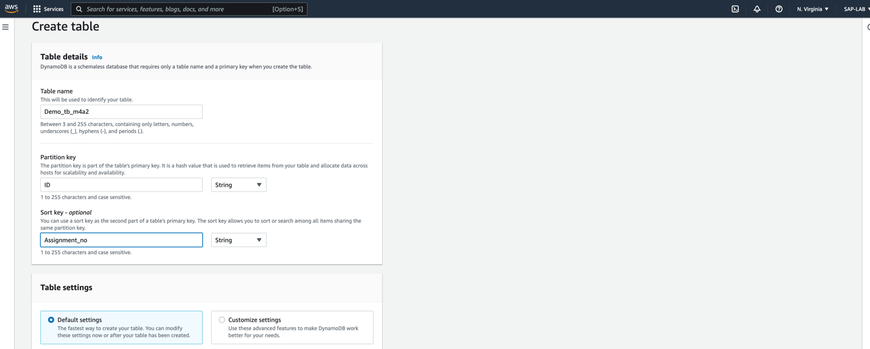

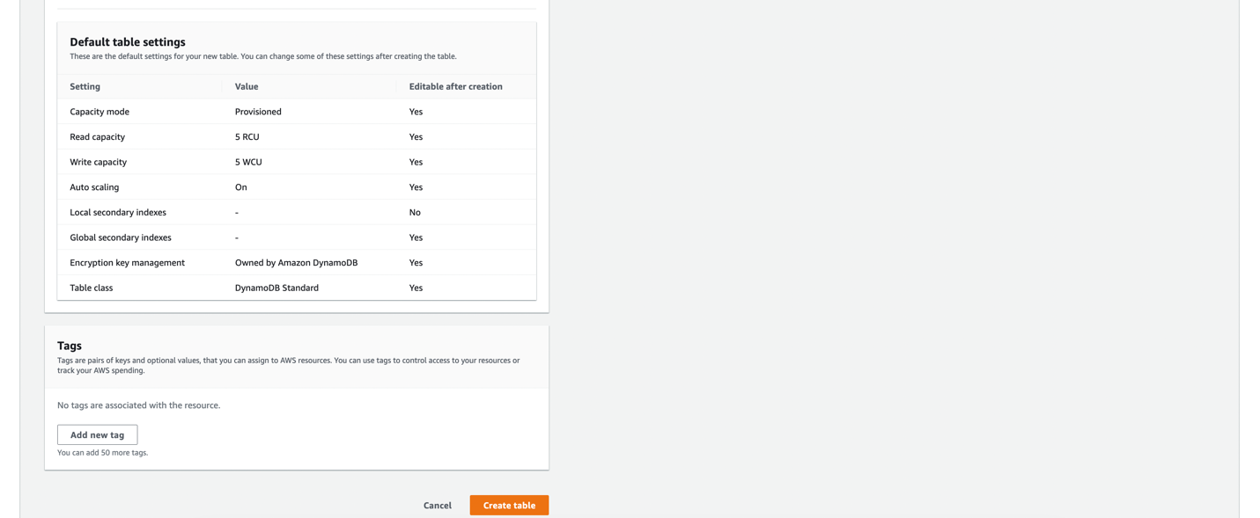

Step 4: Click on table name.

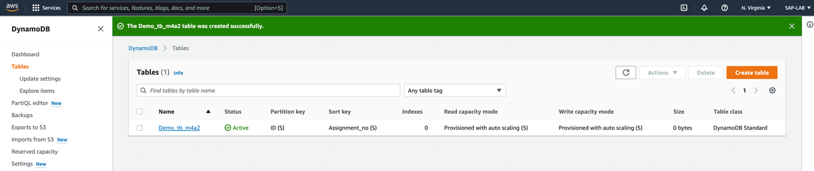

Step 5: Click on ‘**Explore Table items’**

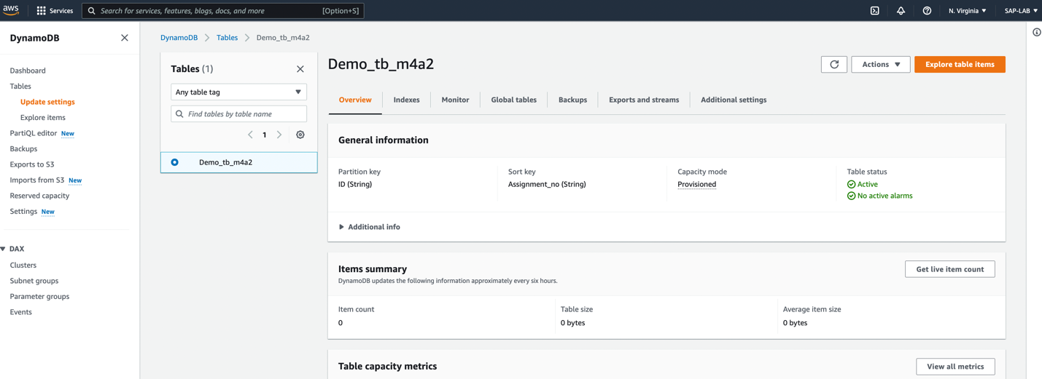

Step 6: Click on ‘**Create Item’**

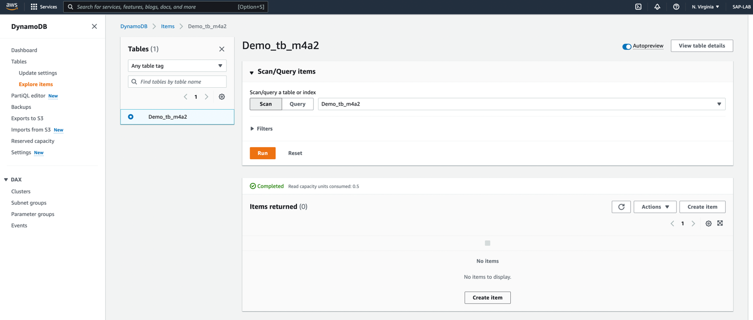

Step 7: put the value for ID Column, Assignment_no column, to add any other column click on ‘**add new attribute’** and click on **create item.**

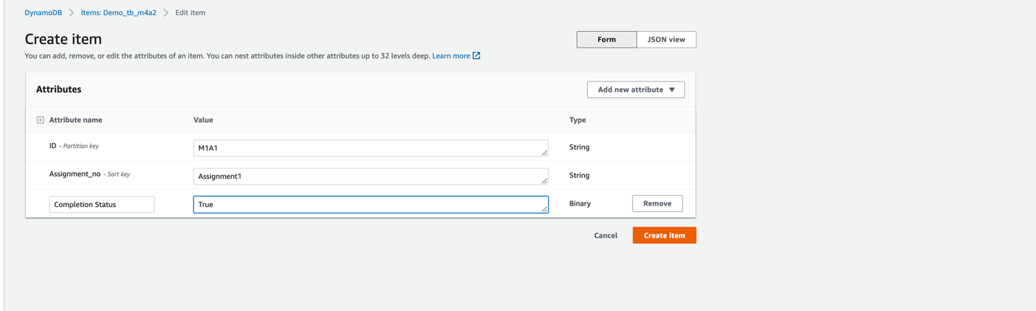

All the added values will be present under the table name.

